Holy Cross Convent Senior Secondary School,Ambikapur
Class -5
Subject -English
Note - Students are requested to write the following notes in grammar
book with pencil.
Chapter -13
Adjectives : Comparison
WORKSHEET

A. Fill up each blank :
1. The base form of an adjective is called its positive degree.
2. The positive degree of an adjective used for comparison is called a
Simile.
3. The comparative degree of an adjective is generally followed by than.
4. The superlative degre of an adjective is generally preceded by the.
5. A simile can be positive or negative.

B. Fill up each blank with the comparative degree of the adjective given
in the brackets :
1. Mothers are generally kinder than fathers. (kind)
2. Rahul is a better batsman than Sayeed. (good).
3. Susan is far slimmer than her sister Nutan. (slim)
4. Horses are more faithful than other animals used for rides. (faithful)
5. This sum is far more difficult than that one. (difficult)
6. The Jama Masjid is larger in size than the Moti Masjid. (large)
7. Apples are costlier than oranges and bananas. (costly)
8. The moonlight is more pleasant than sunlight. (pleasant)

C. Fill up each blank with the superlative degree of the adjective given in brackets :
1. Madhuri is the most charming girl in our school. (charming)
2. The Buland Darwaza is the highest gate in the world. (high)
3. The Taj Mahal is the most elegant tomb in the world. (elegant)
4. Mumbai is the largest city in our country. (large)
5. Indian women are known to be the most faithful wives. (faithful)
6. Mount Everest is the highest mountain peak on the earth. (high)
7. Lord Rama has been the most obedient son indeed. (obedient)
8. At present, gold is the most precious metal in the market. (precious)

D. Look at these pictures and answer the question given below them.

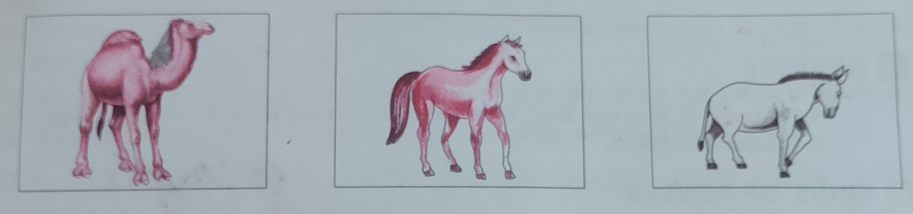
1. Is the horse bigger than the donkey ? Yes
2. Which animal is bigger than the horse ? Camel
3. Which is the biggest of the three animals ? Camel
4. Is the camel smaller than the horse ? No
5. Which is the smallest of the three animals ? Donkey

E. Give each beginning it's correct ending and write the complete sentences:
1. Iron is the most useful of all metals.
2. Persian carpet are more expensive than Indian carpets.
3. Health is more important than wealth.
4. The Himalayas are higher than the Alps.
5. Peacocks are more beautiful than peahens.

